### Phase 1: Weight Controlled Dry Goods Dispenser

# What?

The idea is to build a dispensing system for dry goods, like something I saw in an industrial setting for measuring out powder supplements like creatine. Using the correct amount of ground coffee makes for a better cup and saves money. I want to be able to dispense the ground coffee onto a scale until it reaches a predetermined weight and then programmatically engage a mechanical stop on the dispenser. I want the weight to be easily entered in either standard or metric and the current weight and dispensing weight visible on an LCD. For this project the scale used will need to be accurate between 1-.5 grams.

# How?

I see four parts to this, the dispenser, the scale, the input panel, and the control (Arduino Uno)

### Dispenser

For the dispensing portion I looked into kitchen gadgets and industrial solutions for dispensing fine-grained or powdered chemicals. I saw several approaches, Some involved a sliding latch under a bin like a powder horn, others have a rotating flipper, the best, most accurate design I saw involved an screw that drew small amounts of material from the hopper by rotating inside a tube with opening under the material hopper and over the weighing mechanism.

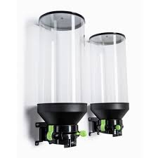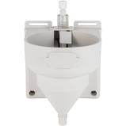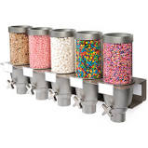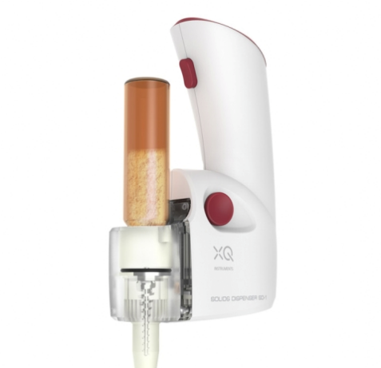

I am going to try and replicate the screw dispenser with a servo motor, a screw (not sure about that yet, I am going to Menards for inspiration) and some small diameter PVC tubing. The servo only needs power, ground and a digital pin. There may be other mechanical difficulties such as material not exiting the machine, I have seen vibrating motors attached to the system to loosen stuck material with short pulses.

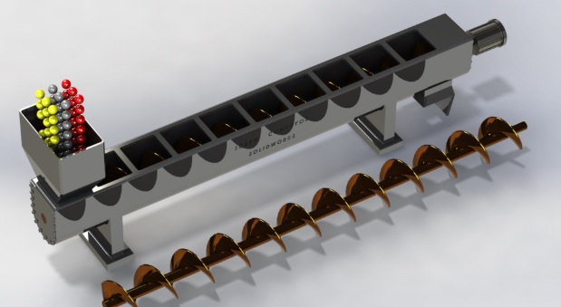

### Scale

For the scale portion, I am going to use the HX711 AD Converter with Breakout module, according to its spec sheets it will be sensitive enough for this project. “Accurately measures forces from 0-5kg\0-11lb” the hookup for this is pretty simple, in needs power, ground and two digital pins

### Input

For the input portion I portion I might just go with a pc interface built over some Processing sketch to communicate through input strings to the serial monitor. The strings might go something like “0,2,29” or 0 = metric, 2 = two decimal places or X * .01, and 29 units of whatever, e.g. “dispense .29 grams of material”

### Control

The Arduino sketch should be straightforward, take an input from the user, run the servo until the scale contains the desired amount and then fire an interrupt to stop the servo. I imagine the servo will need to be stopped some time before the scale hits the exact weight to account for the weight of material still coming out of the dispenser as it stops. There should also be the feature to just run the servo\dispenser, like a set of buttons that runs the servo forward or backward.

### Phase 2: Free Flowing Solids and other problems

My first problem was that certain powdered solids flow easier than others, or more specifically coffee grinds don’t easily flow out of a container with gravity. I opted to use table salt for the rest of the prototyping, as it crystalline structure makes it easier to work with in this situation. My next, or additional problem (I had to figure both things out at the same time really) was the valve portion of my dispenser. I could not find a light or small enough corkscrew, and I didn’t have time to fabricate one. After consulting “507 Mechanical Movements” a book on mechanisms and devices by Henry Brown, I opted to make a sort of pinch valve, with a piece of rubber tubing that would be pulled open or closed.

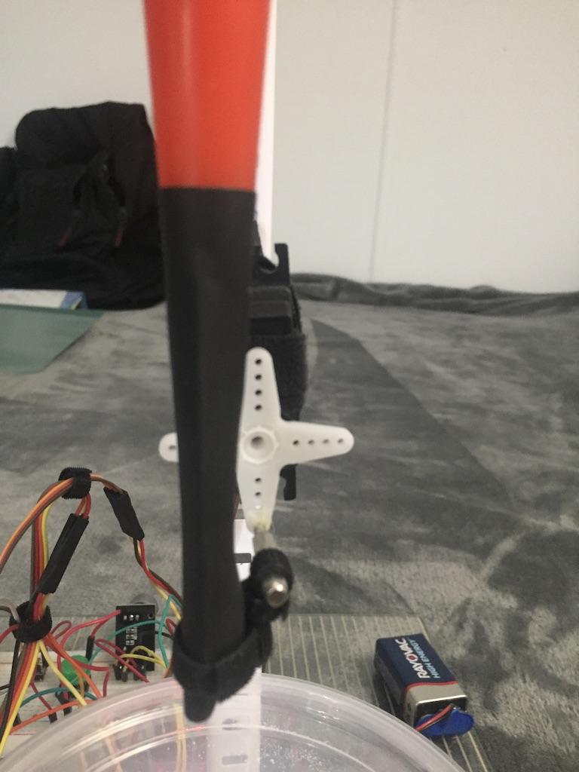 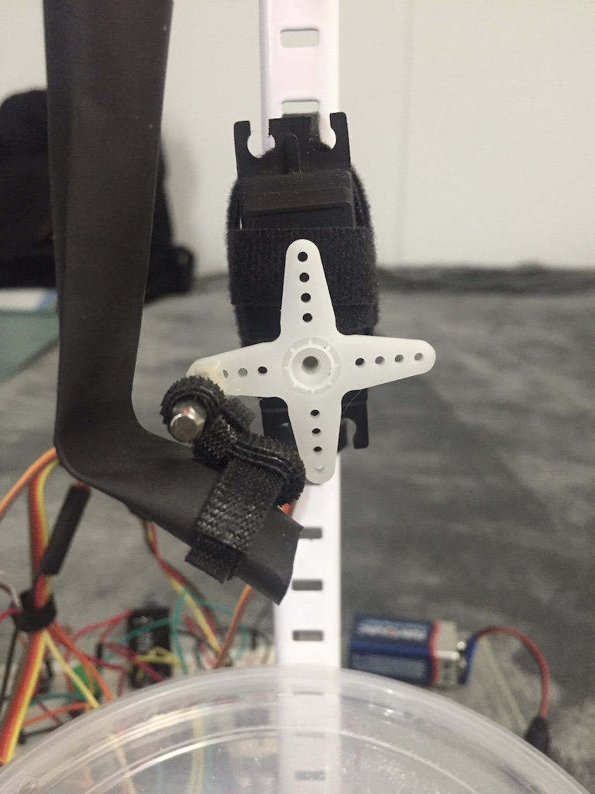

My next design issue was the interface, I had gone back and forth between using a Processing sketch or a physical interface. I really wanted my dispenser to be self-contained and run off a battery. I opted to go with a physical interface, and use the rotary encoder, and some buttons. This introduced some new issues, none of my controls worked, and the bounce was terrible. Every time I rotated the encoder, or pushed any buttons, multiple, or no input would be registered by the Arduino. Another issue was that the rotary encoder would not respond if anything else was happening. I read up on control de-bouncing and tried several approaches at timing the inputs so they would be read clearly.

First Try:



Second Try:

I found two libraries that made my life easier. The first was the Rotary Library by Ben Buxton. This library pretty much solved the main problems I was having with the encoder ie. debounce handling with support for high rotation speeds and correct handling of direction changes mid-step. The second was the Button library by Alexander Brevig. The Button library offered easy solutions to the button bouncing problem, and the project finally started working consistently.

After some development and research my game plan needed to change a little, so I drew up a new domain plan to keep me on task.

**Libraries:**

HX711

LCD_i2c

Wire

Servo

Button

Rotary

**Vars:**

**Rotary Pins: int**

**LCD Address: String**

**Toggle Button Pins: int**

**Enter Button Pins: int**

**Servo:**

Pin: int

Open Position: int

Close Position: int

Runnning: Boolean

**Scale:**

Calibration Factor: float

Value: float

Value To: float

Tolerance: foat

**Primary Run Scenarios**

Power On: scale zeros, set tare

User Rotates Value Selector: Stop value is (clockwise)increased or (counter)decreased

User Selects Run: Servo Run is set to true until read value and stop value are equal, then servo run is set to false

User Selects Toggle: Servo Run is inverted

**Error Scenario**

No scale change after servo run: Servo Run Time counts down, if the Read Value isn’t within 2% of value in 5 seconds, error interrupt and message to user.

Error interrupt: Run vibro 5 sec.

### Phase 3: Scales, and calibration

Another problem I needed to solve was that the HX711 scale element has no idea what it is, or what a gram is for that matter and needs a scaling factor to work properly. I started with the documentation.



I decided to modify an existing Arduino sketch written to calculate this scaling value and get mine figured out. The original sketch required the user to keep hitting + or – into the serial console to get the scaling value right, I modified it to adjust itself until the value matched my known weight on the scale.



After a lot of fiddling, I was able to get my HX711 reporting “accurate weights”, I seem to still be off by around a gram. I believe it might be due to the quality of the sensor or the thermoelectric effect. I also read that in equipment with higher sensitivity, they are using several scale sensors and averaging the readings.

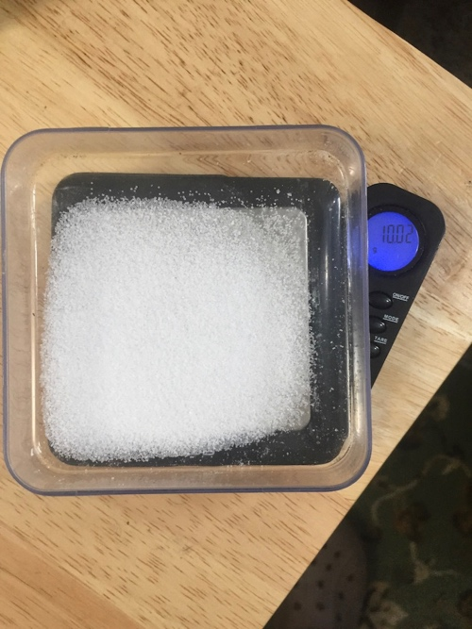 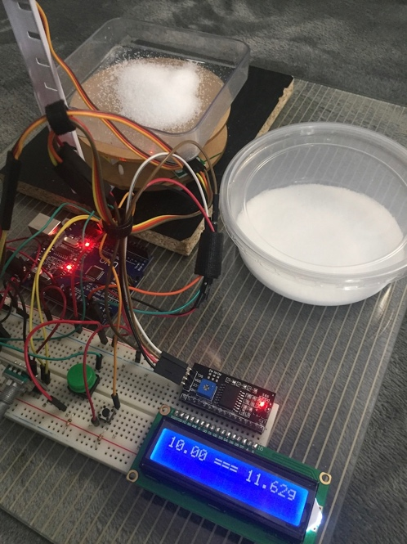

### Phase 4: Keywords

One of the final problems I had was pretty minor, but I learned something new and wanted to relate the experience. I noticed in my sketches that after including a library, some keywords turned orange while other stayed black. I was curious why this was and read up on it. After learning what a proper keywords file is supposed to look like, I made sure the libraries in question were corrected. Now all of my keywords and libraries showed up in orange, nice and neat.

